|  |
| --- |
| Software Development Unit 3 Outcome 1Programming Folio School Assessed Coursework (SAC) Part 3 |

## **This SAC will consist of 4 Folio Tasks over an extended period of time.**

## U3 SAC 1:  Programming Folio (Contributes 10% of subject assessment)

## **Part 1:  T1W6 FRI 5 March (Double)**

## **Part 2:  T1W8 FRI 19 March (Double)**

## **Part 3:  T2W2 FRI 30 April (Double)**

## **Part 4:  T2W4 FRI 14 May (Double)**

**Outcome statement**

*On completion of this unit, the student should be able to interpret designs and apply a range of functions and techniques using a programming language to develop working modules.*

**Task Conditions**

1. **Allowed resources:** Teacher-provided solution designs, open book
2. **Time allocated to this task:** 2 periods (Double) Friday 30 April. **100 minutes**
3. **Marks allocated:** 34  
   **Location of files:** The zipped Visual Basic Project folder is to be submitted for marking Under:
4. **Submission of work: Learning Tasks:** “**Unit 3 SAC 1 Programming Folio 3**”.

**Task Outline**

Using the module requirements and provided designs, students are required to produce working software modules.

**Mr Mac’s Magnificent Motel**

|  |
| --- |
| **713 Vintage Neon Motel Sign Photos - Free & Royalty-Free Stock Photos from  DreamstimeMr Mac’s Magnificent Motel** is a newly established family business in the leafy suburbs of Macville. Mr Mac has requested that you add a user interface form that allows for the management of guests’ room bookings. Rooms are numbered from 1 to 25. |

**Functional Requirements**

|  |  |
| --- | --- |
| **FR** | **Description** |
| **FR01** | Can display a list of room numbers and their associated guest Names (booked rooms) |
| **FR02** | Can display a list of available hotel rooms (rooms not booked) |
| **FR03** | Can assign a room to a guest (make a booking) |
| **FR04** | Can unassign a guest to a room (make a room available) |
| **FR05** | Can search the bookings and state whether a particular room is Available or Not Available. |
| **FR06** | Can search the bookings and state whether a particular guest is currently booked into a room |
| **FR07** | Can search the master Customer File to see whether a particular guest exists |

**Non-Functional Requirements**

|  |  |
| --- | --- |
| **FR** | **Description** |
| **NFR01** | The application form size must fit the dimensions of a laptop |
| **NFR02** | The user interface must be intuitive for the user |
| **NFR03** | Font styles and colours must present a professional appearance |

**Constraints**

|  |  |
| --- | --- |
| **FR** | **Description** |
| **C01** | The solution must be produced on the School laptop |
| **C02** | You must include a linear or binary search |
| **C03** | You must use a user-created function to return whether a room is Available or Not Available |
| **C04** | You must use the Visual Basic .NET programming language |
| **C05** | You must complete the task within 100 minutes. |

**IPO Chart**

|  |  |  |
| --- | --- | --- |
| **Input** | **Processing** | **Output** |
| * The room number | * check to see if the room has an associated guest | * A message whether the room is available or not available |
| * The guest Name | * Check to see if the guest is associated with a room | * A message stating whether a particular guest is currently booked into a room |
| * The guest Name | * Search the Customer File to see if the guest exists in the file | * If the guest exists, the guest details are displayed in the listBox * If the guest is not in the Customer File then display a message that “[guest name] does not exist in the Customer File.” |

**User Interface Mock-ups**

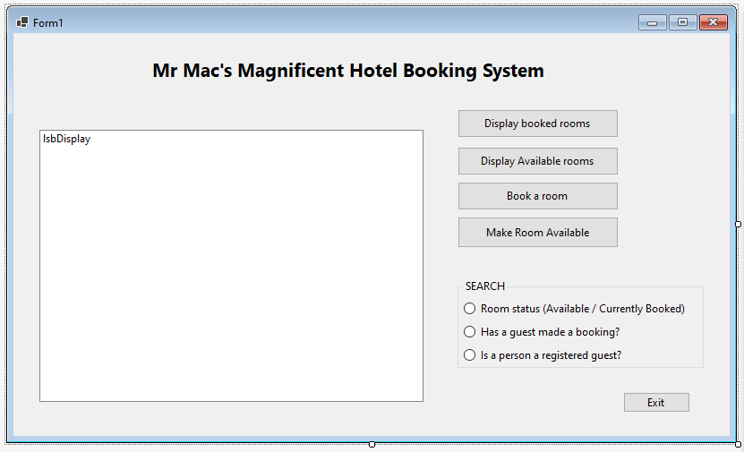

**Testing Table**

|  |  |  |  |  |
| --- | --- | --- | --- | --- |
| **Test No.** | **Test Item** | **Test data** | **Expected Result** | **Actual Result** |
| 1 | Add a key/value pair | **(Combobox) Name:** Aidan Perkins  **(Combobox) Item:** Room 15 | **Listbox: “**Room 15 has been booked by Aidan Perkins" (when display pairs button used)    **MsgBox:** "Booking successful" | As expected |
| 2 | Remove a key/value pair | **(InputBox) Item:** Aidan Perkins | **Listbox:** Line removed (when display pairs button next pressed) | As expected |
| 3 | Display all key/value pairs | Key / Value Pairs Added (booked) via usage of Test 2 | **Listbox: :** "====Listing Pairs===="  Names From Array on each line;  "(Item)… Has Been booked by (Name)"    (Refer to snip for evidence) | As expected |
| 4 | Display a specific key/value pair | **(InputBox**) **Item:**  Room 2 | **Listbox: “**Room 2 is not currently booked” | As expected |
| 5 | Determine if an item has / does not have a pair    (Item paired) | **(InputBox) Item:** Edgar Wright    (Item booked by Edgar Wright) | **Listbox:** "====Search Item Results====" "Edgar Wright has booked room 22" | As expected |
| 6 | Determine if an item has / does not have a pair    (Item not paired) | **(Inputbox) Item:** OttoKing    (Otto King has not booked) | **Listbox:** "====Search Item Results====" "Otto King has not currently booked a room" | As expected |
| 7 | Search (linear) a textile to state whether a name is in the file    (Item in file) | **(InputBox) Name:** Otto King    *Name is in file | **Listbox:** "====Search Name Results====" "Otto King is a registered guest" | As expected |
| 8 | Search (linear) a textile to state whether a name is in the file    (Item not in file) | **InputBox) Name:** Jimbob Bobsmithson    *Name is not in file | **Listbox:** "====Search Name Results====" "Jimbob Smithson was not found in the customer file" | As expected |
| 9 | Displays room availability | All available rooms added from dct | **Listbox**: “====Available Rooms====” “Room available on each line) | As expected |

|  |  |  |
| --- | --- | --- |
| **Test No.** | **Test Item** | Snip |
| 1 | Add a key/value pair |  |
| 2 | Remove a key/value pair |  |
| 3 | Display all key/value pairs |  |
| 4 | Display a specific key/value pair |  |
| 5 | Determine if an item has / does not have a pair    (Item paired) |  |
| 6 | Determine if an item has / does not have a pair    (Item not paired) |  |
| 7 | Search (linear) a textile to state whether a name is in the file    (Item in file) |  |
| 8 | Search (linear) a textile to state whether a name is in the file    (Item not in file) |  |
| 9 | Displays item (room) availability |  |

**'NOTE**: Room availability search and guest booking search function only AFTER a booking has been made

**'JUSTIFICATIONS:**

'--**Visual Basic .NET** framework was suitable given built-in features such as ability to easily read and save

'--data from textfiles via StreamReader, and GUI creation options.

'--**Do...While Loop** statements were suitable as it is a control flow statement that can execute a block of code repeatedly until

'--meeting a condition at the end of the block. This was used as part of adding names from the textbox into the combobox,

'--looping through until the last name had been added, and in other subroutines.

'--**IF...Else statements** were suitable as it allowed execution of code given specified criteria was met (TRUE), while

'--another set of code evaluated FALSE. IF statements were used in conjunction with boolean Yes/No to add key/value pairs when

'--borrowing items and in other subroutines.

'--**Try...Catch statements** were suitable as it allowed a block of code to be tested for errors, and for another block of code to

'--be executed if an error did occur in the try statement via the catch. This was used to check if the user input both a key and

'--a value into the comboboxes, and prompt a msgbox telling them they had not if an error occured.

'--**Select Case statements** suitable as allowed for a specific block of code to be executed out of seleceted radiobox options.

'--This was used for the 3 search options to execute different coded for each search.

'--**For...Next statements** were suitable as it is an iterative, incremental loop statement used to repeat sequence of

'--statements for specific number of circumstances. Was used for searches to check whether items were borrowed, requiring only

'--one line to be published to the listbox as an output rather than multiple, which could be specified by this statement. Also

'--used to read through 100 lines of names in textbox and added to them an array.

**'VALIDATION:**

'Comboboxes validated via private action subroutine for validation and actions run when book room button is clicked

'using type, range, and existence checks

**Marking Scheme**

Each task will be assessed using the provided performance descriptors and table below.

|  |  |
| --- | --- |
| **Criteria / Skills** | **Marks Available** |
| Interpretation of designs to produce working modules | **3** |
| Data types and structures used | **3** |
| **Use** appropriate processing features of a programming language to develop working modules | **13** |
| **justify** appropriate processing features of a programming language to develop working modules | **4** |
| Develop and apply suitable validation techniques | **4** |
| Develop and apply suitable testing and debugging techniques using appropriate test data | **4** |
| document the functioning of modules and the use of processing features through internal documentation | **3** |
| **TOTAL** | **/34** |

VCE Applied Computing: Performance Descriptors

|  |  |  |  |  |  |
| --- | --- | --- | --- | --- | --- |
| **SOFTWARE DEVELOPMENT UNIT 3 OUTCOME 1 - SCHOOL-ASSESSED COURSEWORK** | | | | | |
| **Performance Descriptors - typical performance in each range** | | | | | |
| ***Unit 3***  ***Outcome 1***  ***Interpret teacher-provided solution requirements and designs, and apply a range of functions and techniques using a programming language to develop and test working software modules.*** | **Very low** | **Low** | **Medium** | **High** | **Very high** |
| Limited interpretation of solution requirements and designs to develop working modules. | Some interpretation of solution requirements and designs to develop working modules. | Sound interpretation of solution requirements and designs to develop working modules. | Most solution requirements and designs are interpreted accurately to developing working modules. | All solution requirements and designs are interpreted accurately to developing working modules. |
| Limited selection and use of data types and data structures. | Some selection and use of appropriate data types and data structures. | Sound selection and use of data types and data structures to develop working modules. | Detailed selection of relevant data types and data structures to develop working modules. | Comprehensive selection of relevant data types and data structures to develop working modules. |
| Limited selection and use of processing features of the programming language to develop some working modules. | Some selection and use of appropriate processing features of the programming language to develop some working modules. | Sound selection and use of appropriate processing features of the programming language to develop some working modules. | Most processing features of the programming language have been selected and used to develop all working modules. | Comprehensive selection and use of relevant processing features of the programming language to develop all working modules. |
| Limited explanation of how the selected processing features are used to develop working modules. | Some justification and explanation of how the selected processing features are used to develop working modules. | Sound justification and explanation of how the selection of appropriate processing features are used to develop working modules. | Detailed justification and explanation of how the selection of appropriate processing features of the programming language are used to develop working modules. | Comprehensive justification and explanation of how the selection of appropriate processing features of the programming language are used to develop working modules. |
| Limited data validation techniques are applied to check the reasonableness of some input data. | Some data validation techniques are effectively applied to check the reasonableness of some input data. | Sound use of data validation techniques are effectively applied to check the reasonableness of input data. | Detailed use of relevant data validation techniques are applied to efficiently and effectively check the reasonableness of all input data. | Comprehensive use of relevant data validation techniques are applied efficiently and effectively to check the reasonableness of all input data. |
| Limited range of test data is expressed in a testing table, with incomplete or missing results. | Some testing of test data is expressed in a testing table with actual output stated. | Sound range of testing of test data is expressed in a testing table, with both expected and actual output stated and some evidence of debugging. | Detailed use of test data is expressed in a testing table, with both expected and actual output stated with evidence of debugging. | Comprehensive use of test data is expressed in a testing table, with both expected and actual output stated, and showing detailed evidence of debugging. |
| Limited internal documentation with few comments regarding the use of the selected processing features. | Some internal documentation with comments regarding the functioning of modules and the use selected processing features. | Sound use of internal documentation with comments regarding the functioning of modules and the use of selected processing features. | Most software modules include detailed internal documentation regarding the functioning of modules and use of selected processing features. | All software modules include comprehensive internal documentation regarding the functioning of modules and use of selected processing features. |

KEY to marking scale based on the Outcome contributing 100 marks

|  |  |  |  |  |
| --- | --- | --- | --- | --- |
| Very Low 1–20 | Low 21–40 | Medium 41–60 | High 61–80 | Very High 81–100 |